**STEPS**

**(Student-Transferee Enrolment Processing System)**

**Class Diagram**

**Admin**

**Login/Logout Class Diagram**

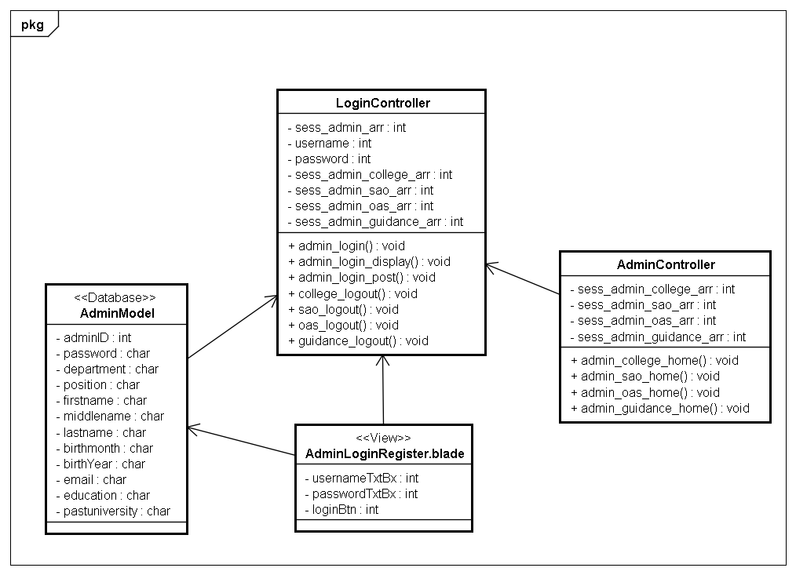

**Admin**

**Register Class Diagram**

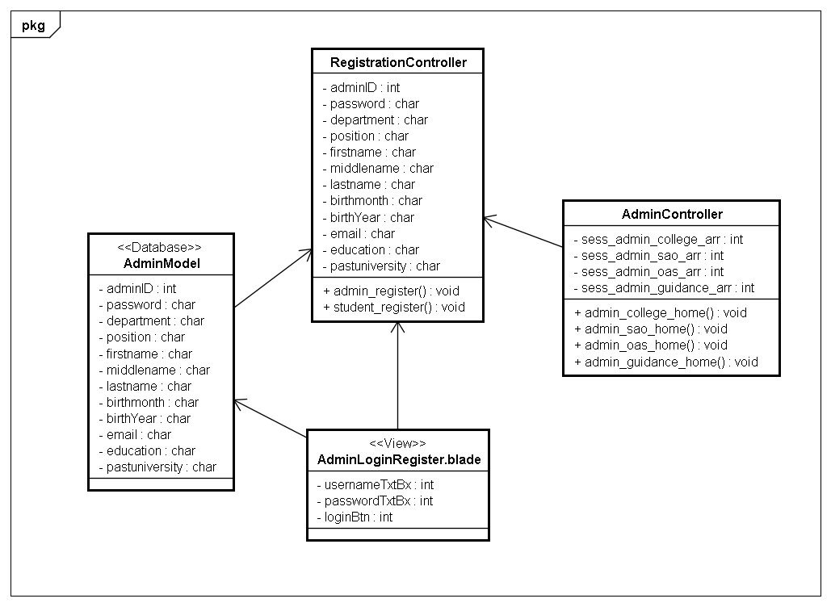

**Admin**

**College Class Diagram**

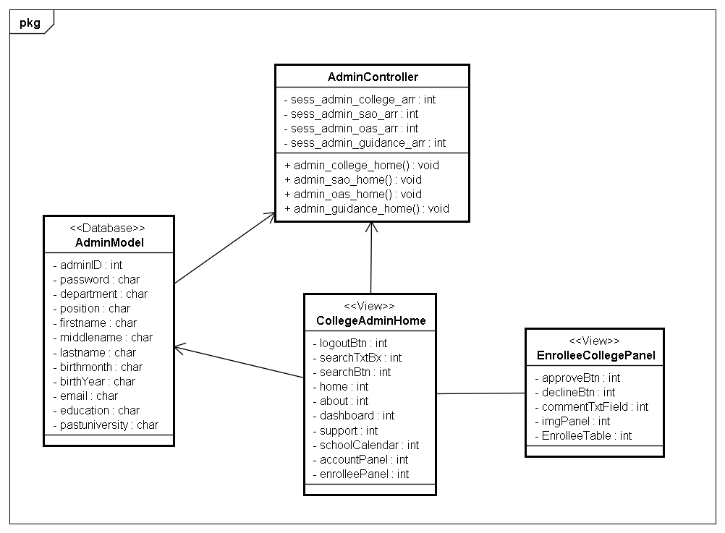

Admin

SAO Class Diagram

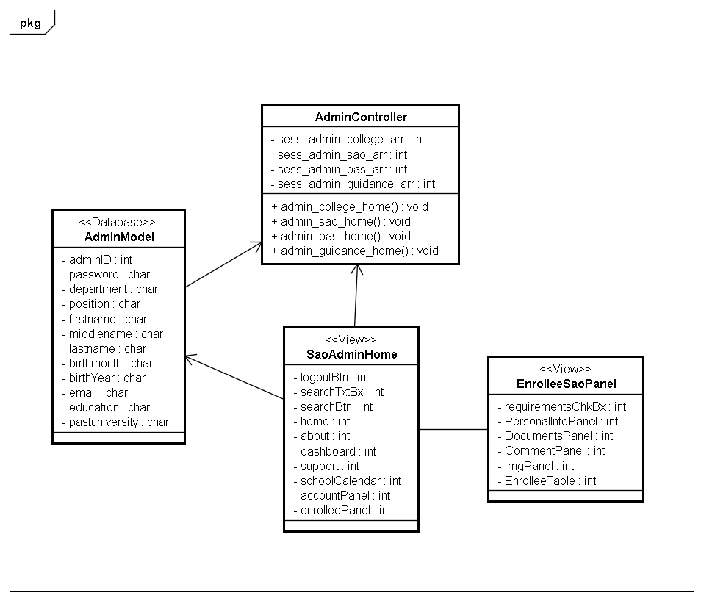

Admin

OAS Class Diagram

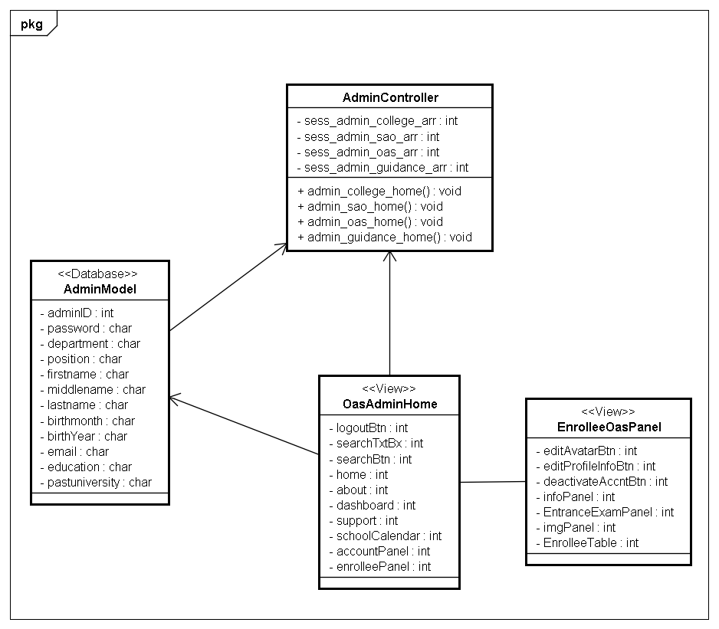

Admin

Guidance Class Diagram

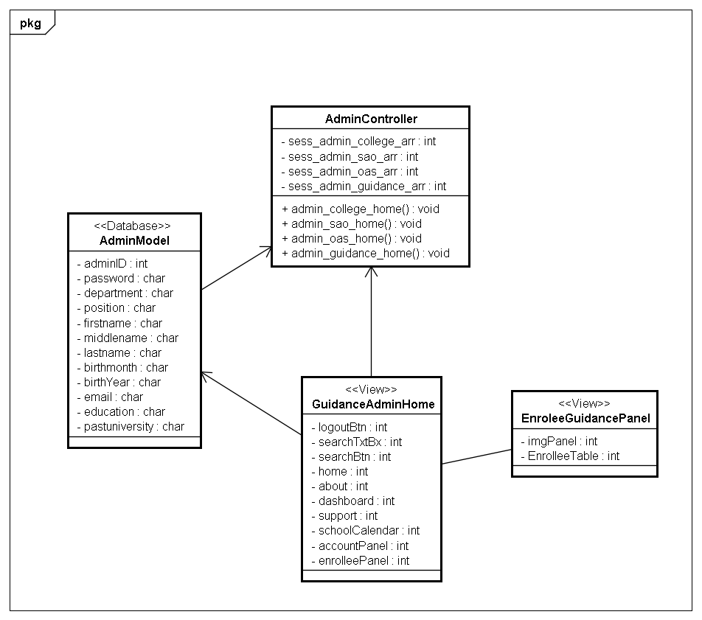

Student

Login/Logout Class Diagram

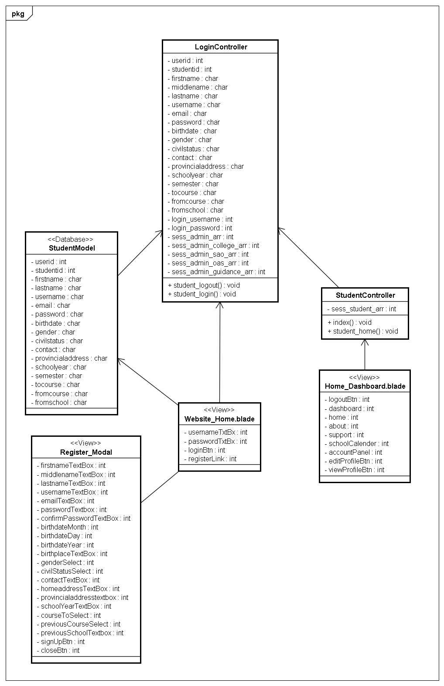

Student

Register Class Diagram

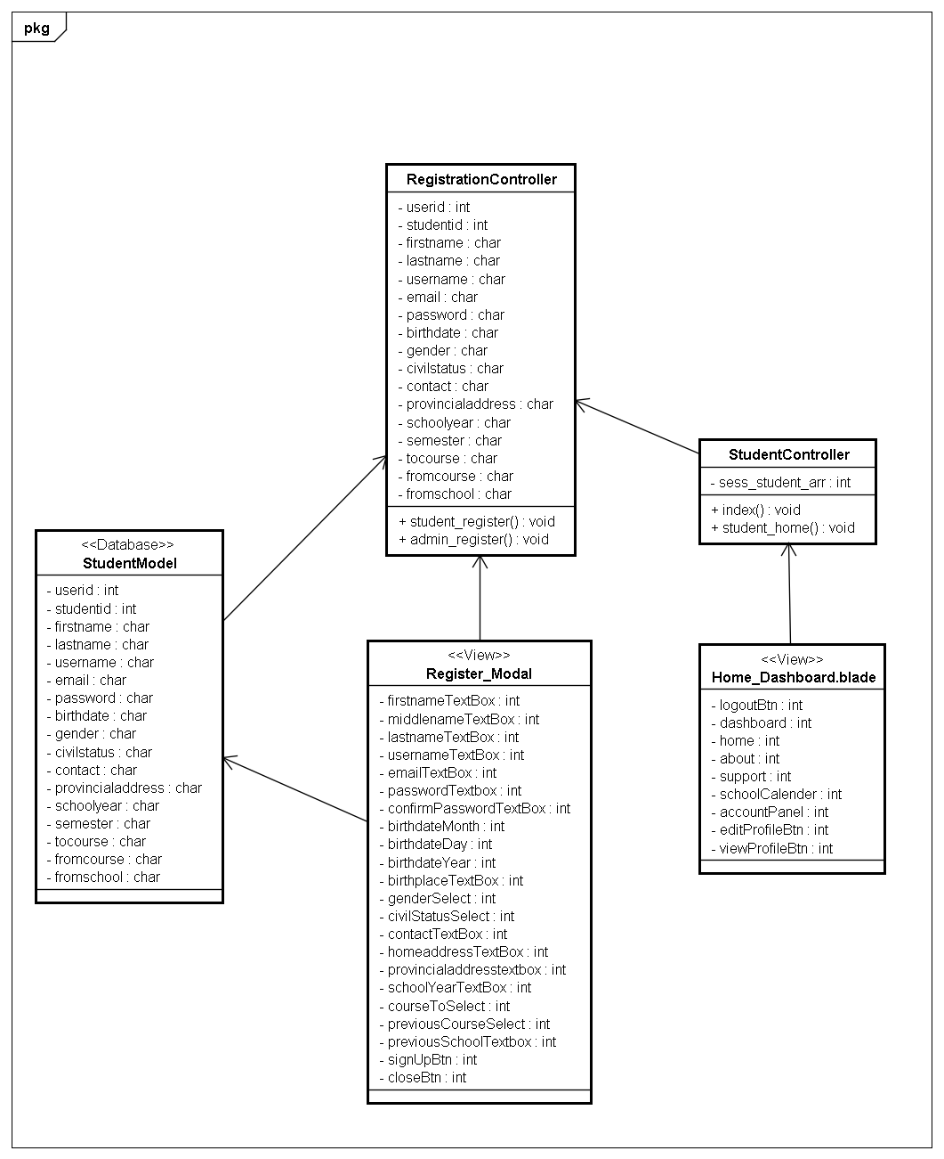

Student

Application Class Diagram

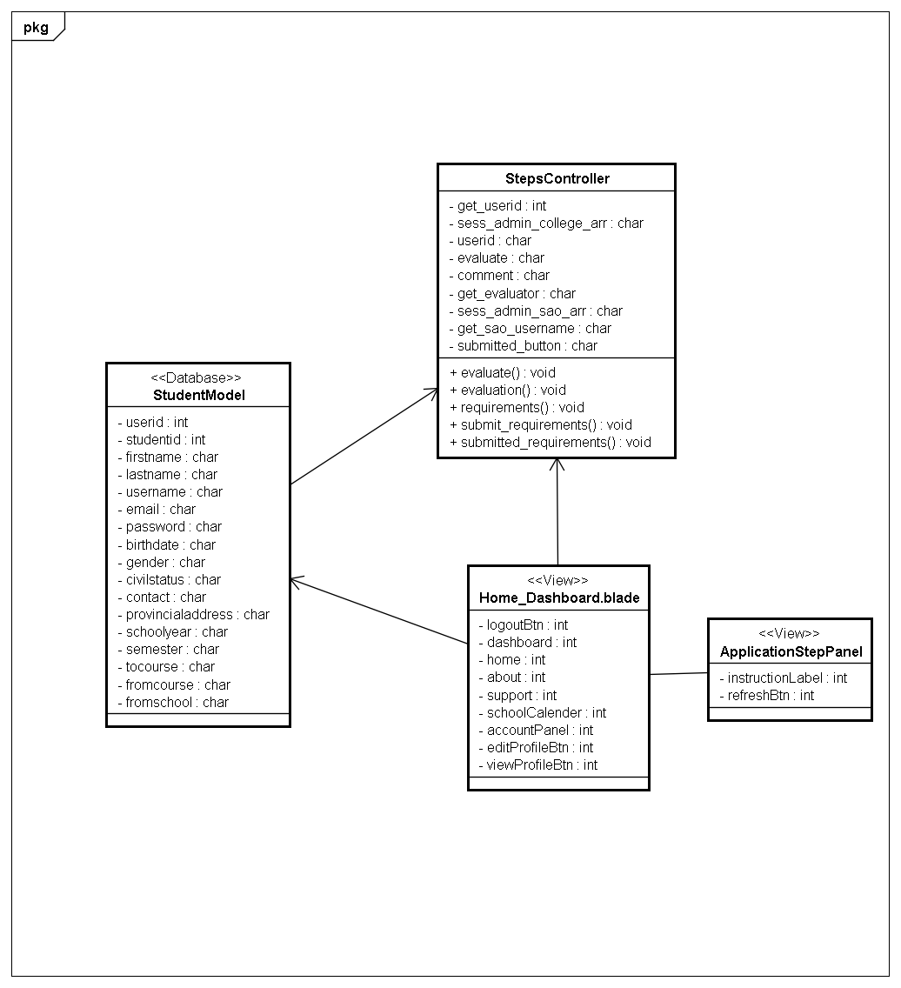

Student

Payment Class Diagram

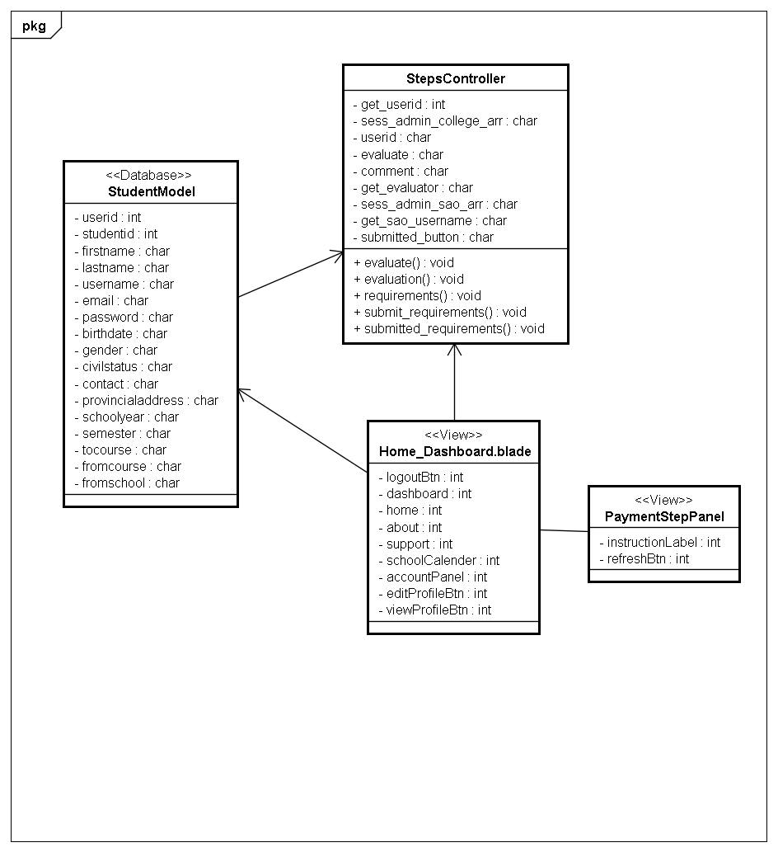

Student

OAS Class Diagram

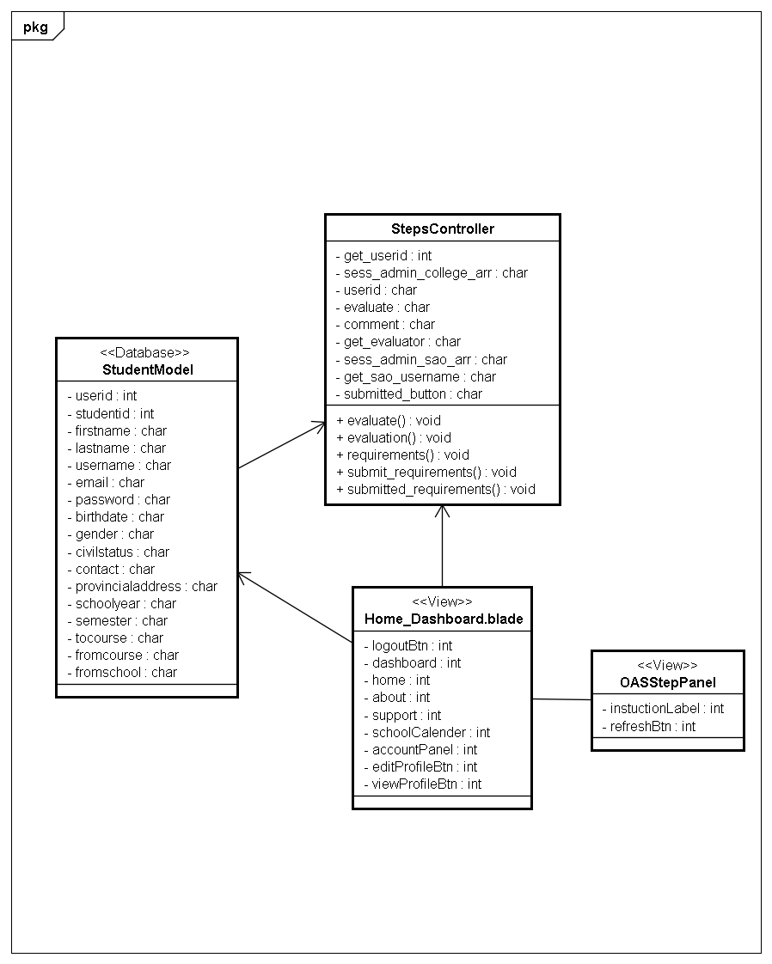

Student

Entrance Exam Class Diagram

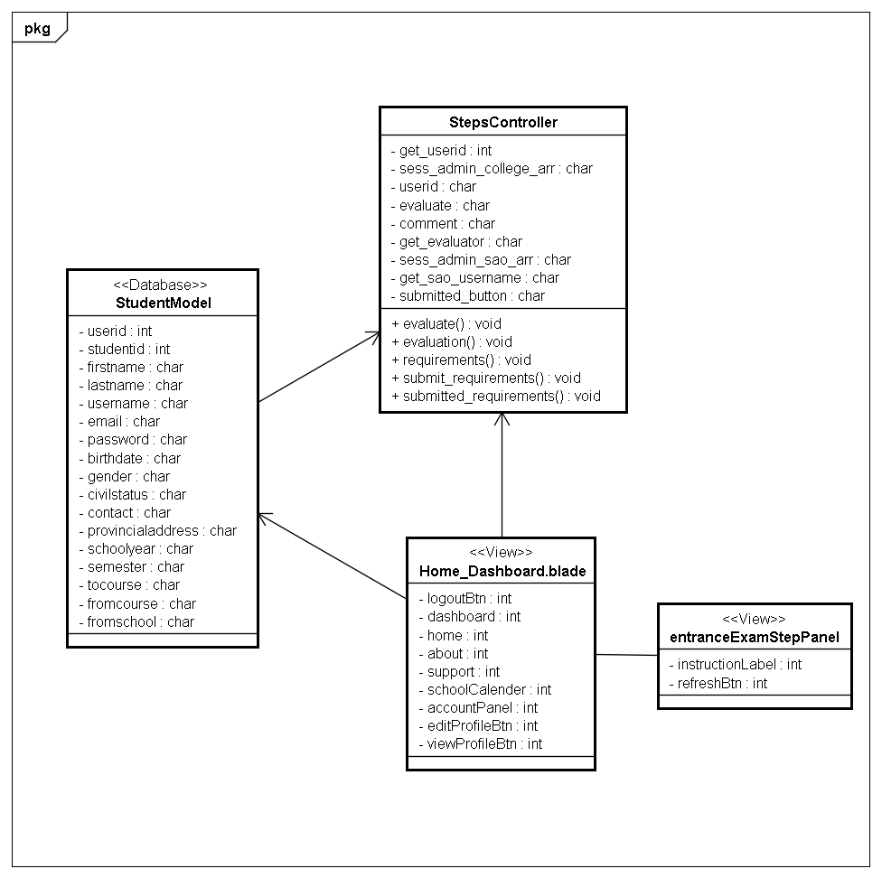

Student

Interview Class Diagram

